

From tiny seeds, great trees grow’

Prospectus

Our aim;

“Our aim is to provide a safe, secure environment which is dedicated to all children’s involvement, well-being and learning whilst working in partnership with parents & professionals to become inspired, confident and curious learners.

‘ From tiny seeds, great trees grow’.

Introduction

We would like to welcome you to our setting. Choosing childcare for your child(ren) can be a daunting and tedious task, so many questions and information to be asked and obtained. We hope that this prospectus will walk you through all of the benefits of selecting Bambini as your childcare provider.

All about us

With funding from the New Opportunities Lottery Fund for our Out of School Care facility, Bambini Childcare Ltd opened in October 2000. We are now a Limited Company by guarantee (non-profit) business, managed by a voluntary group of directors, who are extremely dedicated and enthusiastic about childcare. We are registered with Ofsted and we are inspected by this body to ensure minimum welfare requirements are met. Our registration is for 52 children at any one time. We offer day care provision for children from 2 years old, children may attend half or full days making these facilities more accessible for parent’s individual needs.
Along with our preschool sessions, we also offer before and after school care for children aged between 3-11 years, this facility operates during term time. All of our facilities are co-ordinated to support and enhance our provision to meet the differing needs of families and the community.
We work in partnership with St Michael’s Children and Family Centre to provide family support and signpost to other support groups and professionals.

Opening Hours

Our opening hours are 8.00am to 6.00pm Monday to Friday. We are open 38 weeks a year, operating Term Time Only.
As we are continuously striving to evaluate, adapt and improve our provision, if there is any additional information we can add to this booklet please feel free to approach a member of the team. We value any input from our parents/ carers. Alternatively, you can call us on 02476 316104.
The setting is led and managed by Anna Fielding. Anna holds a Level 3 in Childcare, Learning and Development and has over 18 years childcare experience. Deputising the lead of the setting is Sian Burgess. Sian has over 18 year’s childcare experience and holds a Level 4 in Children, Families and Community health.
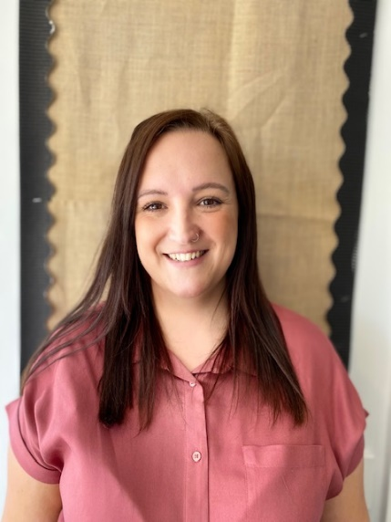
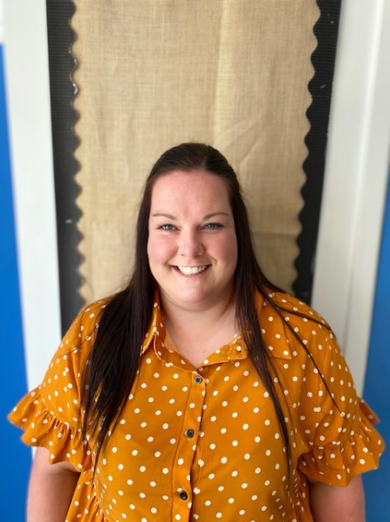
.

Anna Fielding Sian Burgess

Parent/Carers Partnerships

“Parents are children’s first and most enduring educators, when parents and practitioners work together in early years settings, the results have a positive effect on children’s development and learning.”
Early Years Foundation Stage

Bambini is committed to strong parent/carers relationships, local community and school links to enhance a child’s transitional period between previous care settings i.e. home, child minders etc… to preschool experience and then onto the significant first year of their school life. With this in mind we offer a relaxed open door policy with parents, this offers ease of access to information regarding your child’s development journey with us.
Before your child begins their journey we build up a wide range of detailed information to aid us with their medical, dietary, religious, settling and developmental needs. This information is then passed to their Key Person who will use this to plan in the moment for your child individually based on their age and stage of development.
We believe all children are individuals and will develop at their own pace, through play, enjoyment and challenging provision and activities. Children enjoy experimenting and exploring in their learning environment. Through play they gain huge enjoyment whilst building upon skills that will help them thrive during their childhood. Every child is an individual and is allocated a ‘Key Person’ who will work closely with you at all times to give them the best possible standard of care and education, and act as a point of contact to discuss your child’s development. We welcome parental input as you know your child best and how you would like them to be cared for.
We also keep you posted of upcoming events, trips, news and useful information with regular newsletters and posts on our Facebook page and also through our online communication/learning portals Class DoJo and Tapestry.
Bambini works in Partnership with St Michael’s Children and Family Centre; we work together to provide a flexible and high quality family support service. The centre offers a range of services such as adult learning workshops, ICT, Literacy and short courses. They also provide support to children and their families through support workers and a variety of useful tools to assist parents.

Did you know?...

“The earlier in a child’s educational process parent involvement begins, the more powerful the effects”

Cotton & Wikelund (2001)

“The frequency with which a child plays with letters/numbers at home was linked to higher attainment across all areas”

The Effective Provision of Pre-School
Education (EPPE)

“Very high parental interest is associated with better exam results, than for children whose parents showed no interest”

You really can make a difference please get involved as much as you can!
We are here to offer support and advice, please speak to your key worker we’d love to help.

Give us your input!

All parents can contribute to the children’s experiences. We use the learning portals Class DoJo and Tapestry to enable you to input any new learning that the children have done at home. You will then meet with your child’s key person three times in the year to discuss learning and development, however parents are always able to come and speak to staff if needed and regular feedback will be given at collection time.

Financial Support for Parents

We access Early Education Funding for children the term after their third birthday, this then entitles your child to 5 funded preschool sessions which you can use to suit your requirements E.g. you may choose to select two full days and one-half day session. A maximum of 5 sessions per week will be offered to preschool aged children for a maximum of 38 weeks per year. We also offer the 30-hour funding for eligible families who meet certain criteria within our Little Treasures provision. We offer care for two-year-olds from 8.0am-6.00pm. You can claim funding for this if eligible (please speak to a member of staff to check eligibility) you will be entitled to 15 hours per week childcare. Please look for the new incentive for working parents who have children aged 2 years from April 2024 in which you can claim 15 hours universal funding (subject to meeting criteria). More information to follow.
Please note – Your funding entitlement does not cover any additional wrap around costs. If accessing wrap around care you may be eligible to claim Universal Credit to support with these costs dependent upon your individual circumstances.

Childcare vouchers

Parents can also access the tax-free childcare system in which the Government support families in contributing to childcare costs (for every £8 parent add into their tax-free childcare account the Government add an additional £2 to top this up to £10). Please visit the website below for more information:
https://www.gov.uk/tax-free-childcare

Your Child’s Care, Learning and Development

We strongly believe children should enjoy their learning experience and offer a home from home learning experience that develop children for their future ‘from tiny seeds, great trees grow’.
The curriculum - ‘The Birth to Five Matters’ bases play at its heart and it builds upon the firm foundations needed for a child to become a confident and competent learner. We feel children should be able to develop at their own pace through play and encouraging, challenging learning experiences and scaffolding this learning through exciting experiences. Children here at Bambini are allocated a Key Person, who’s roles includes; building strong relationships with you and your child right from the start of your home visits; documenting and sharing in your child’ successes, giving your child reassurance to feel safe, and to meet the individual needs of all the children in their care.
We expose children to a wide range of play opportunities that are suited to their age and promote all areas of their development, these opportunities are offered throughout our indoor and outdoor classrooms. We begin with children’s personal, social and emotional development and communication and language as we feel a secure foundation is paramount for learning and development, moving onto the remainder of the prime areas of the Birth to Five curriculum Framework.
Areas of Learning and Development

Personal, social and emotional development involves helping children to develop a positive sense of themselves, and others; to form positive relationships and develop respect for others; to develop social skills and learn how to manage their feelings; to understand appropriate behaviour in groups; and to have confidence in their own abilities.

Communication and language development involves giving children opportunities to experience a rich language environment; to develop their confidence and skills in expressing themselves; and to speak and listen in a range of situations.
Physical development: involves providing opportunities for young children to be active and interactive; and to develop their co-ordination, control, and movement. Children must also be helped to understand the importance of physical activity, and to make healthy choices in relation to food. We ensure that our outdoor area is free-flow at all points throughout the session to encourage children to access outside for at least 3 hours per day.
Literacy development: involves encouraging children to link sounds and letters and to begin to read and write. Children must be given access to a wide range of reading materials (books, poems, and other written materials) to ignite their interest and ensuring that the learning environment is rich with print and materials for children to begin to acknowledge letters.

Mathematics: involves providing children with opportunities to develop and improve their skills in counting, understanding and using numbers, calculating simple addition and subtraction problems; and to describe shapes, spaces, and measures.

Understanding the world: involves guiding children to make sense of their physical world and their community through opportunities to explore, observe and find out about people, places, technology and the environment.

Expressive arts and design: involves enabling children to explore and play with a wide range of media and materials, as well as providing opportunities and encouragement for sharing their thoughts, ideas and feelings through a variety of activities in art, music, movement, dance, role-play, and design and technology.
As your child progresses our dedicated team will provide resources that will equipment them with essential skills for school and we work very closely with reception class teachers to provide the best possible starting point for your child. We discuss with children their transition onto a new learning journey and give them the confidence to look forward to the new phase in their life.

Settling in

All children are individuals and will settle at differing rates. We encourage you to visit the setting as much as possible, you will be offered visits over a week period the week before your child is due to start, this is a fantastic time to meet your child’s Key Person, discuss your child’s needs, to meet the team and to also get a feel of the routine and sessions we offer. These visits will help your child to become comfortable in the setting; we can also show them where their peg and draw will be.
We are happy to accommodate as many visits as you need to feel comfortable when leaving your child with us. Please feel free to bring a comfort object, such as a favourite teddy or toy when settling, as this helps children by having a link to their home life.
Who will be looking after my child?
We value the importance of a welcoming atmosphere with approachable staff. All our staff have a good sound knowledge of childcare and high quality experience. We welcome students and volunteers into the setting and work closely to develop them as leading professionals.
Our staff team have a mix of qualifications and experience so the children get a wide breadth of skills and childcare knowledge. We have a low staff turnover, and the majority of the staff have been with us for 3 years plus.
All staff are DBS checked in line with the settings safeguarding and safe recruitment policies.

Senior Leadership Team and Designated Safeguarding Leads
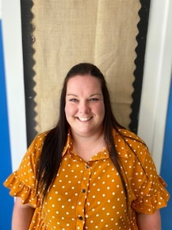
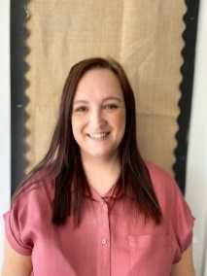
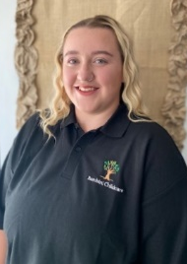
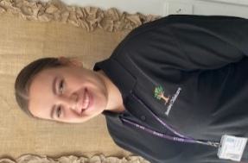

Melody- Room Lead of Little Treasures
Sian-
Deputy Manager/ Director
Anna -
Manager/ Director
Becky- Room Leader of Mini Gems

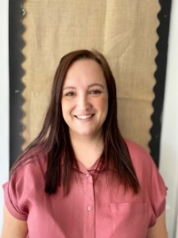
Director Committee


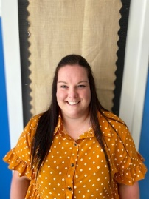


Julie
Sarah
Emma
Sian
Anna

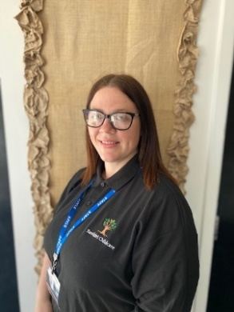
Little Treasures Team (pre-school)
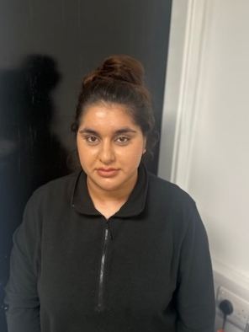
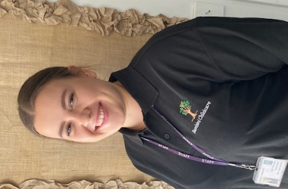

Georgia
Nursery Practitioner – currently on maternity leave
Zahra
Nursery Practitioner
Melody
Room Leader

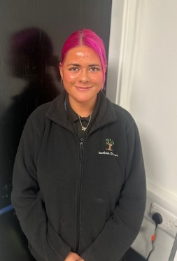

Lauren
Nursery Practitioner
Danielle
Nursery Practitioner

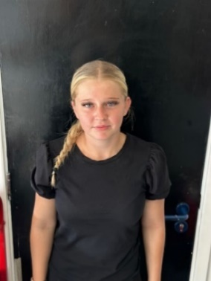
Mini Gems Team- two-year provision
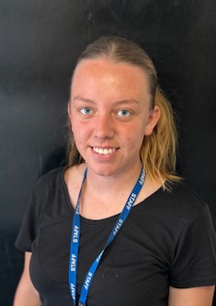
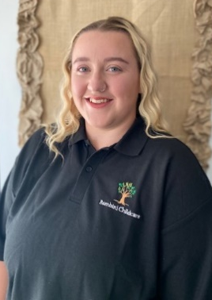

Lauren
Nursery Practitioner
Lucy
Nursery Practitioner
Becky
Room Leader

Shooting Stars After School Club Team

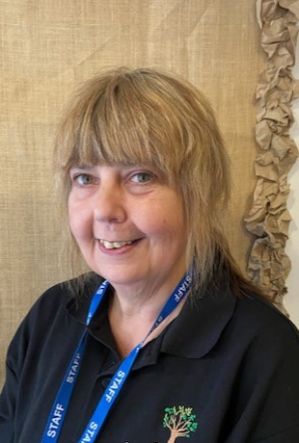
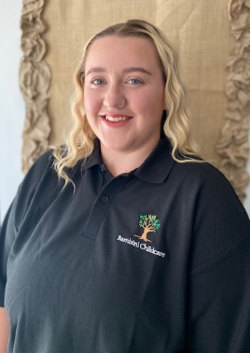

Melody
Play Leader
Karen
Play worker
Rebecca
Play Worker

We maintain strong adult to child ratios. The Nursery Manager and Deputy Manager are not included in the room staffing, they work with the children and staff to nurture best practice and support new working methods, this enables our management team time to meet and review the effectiveness of the setting. All staff work to a personalised, professional development training plan; this helps staff to identify strengths, weaknesses and the opportunity to evaluate their work.

General Information

Healthy Children
A healthy life style is paramount, we must start as children’s first educators to encourage healthy choices, all of our ‘Snacks’ are a healthy choice, we offer:-
Breakfast Club: Cereal /fruit/ Toast (wholemeal option available), pancakes with a drink of fresh milk and water.
Pre-School: Fresh fruit bowl available at our snack bar for children to access freely, along with a choice of Fresh milk and fresh drinking water. We also offer a fruit of the week and snack of the week where we introduce children to various foods from around the world.
After School Club: We have a two week rolling menu for snack; we have healthy wraps, a salad bar, crumpets, ploughmen’s, fruit salad etc...
Fresh fruit is available throughout the whole session for children to snack on.
Fresh drinking water is available for children to access independently throughout all sessions, indoors and outdoors.
All snacks are prepared on site and all staff hold a relevant food hygiene qualification.

Clothing

We enjoy messy play here and it would be advisable that you do not send children in their best clothes as we cannot ensure their protection. Please choose clothing that children can access independently when going to the toilet so that they do not have to feel dependant on others to help.
We ask that you supply a spare set of clothes in a drawstring bag on their peg, as sometimes children may have an accident or other such occurrence.
- Please make sure that your child has adequate outdoor clothing suitable to the weather as we have an outdoor classroom, that children have the right to access freely regardless of the weather conditions.
- Wellie boots may also be kept at the setting, so we can go outdoors in damper conditions.
- Please do label all your child’s clothing as this stops the lost property box looking so full.

Uniform

To keep your child’s clothes like new we have a uniform, it is not compulsory however, but parents have commented how much easier it is and how much it prepares children for school. The uniform is available to purchase from the Bambini office. Please allow 10 working days for delivery of stock.

Sweatshirt- £12.50 polo t-shirt £11.50 cap- £6.50 drawstring bag- £7.50

Available in sizes 1-2 years, 3-4 and 5-6 years, special orders can be placed for differing sizes. In your induction pack you will receive an order form or you can order uniforms when you visit the pre-school during settling visits alternatively you can telephone through your order. All uniforms are charged a cost price to keep pennies in your pocket!

Admissions Policy

We operate an Admissions policy that is open to all children regardless of Race, Ability, Religion or Disability. We are committed to working closely with you to accommodate your child’s needs and will exhaust all of our resources to do this.
After reading this prospectus, if you feel Bambini is suitable and your child will be happy here, just complete the attached request form and your child’s name will be added to our waiting lists. The list works on a termly first come first serve basis to ensure fairness. Once we have your form you will receive an acknowledgment letter informing you when we will be contacting you again with regards to the home visits.

Home Visits

Before your child can join us here there is lots of information and paper that needs to be discussed and completed. We conduct home visits where you can meet your child’s key person and the Manager attends also and fills out all the necessary paperwork such as going through our induction pack and our policies and procedures. This is a great opportunity to tell your child’s key person all they need to know. The visit usually lasts approximately 45 minutes. It’s a great way to equip you with everything you need to know, and for your child to meet their key person in the familiar area of their own home!
You will receive a letter informing you of when your home visit will be and you will be asked to confirm this date and time. This will be the half term before your child starts here with us. Your child cannot start with us until we have completed the necessary paperwork including the registration form.

Additional Needs

We are aware some children have additional needs that may require additional support, whether that is an educational or physical need Bambini will take a personal and tailored approach to this, and work in line with the SEN Code of Practice. We ensure that all children have a fair opportunity to participate in our provision. We have two fully trained Additional Needs Co-ordinators (ANCO) – Anna Fielding and Sian Burgess and our aim is for each child to fulfil his or her potential whist accessing a stimulating and nurturing environment. We work very closely with Multi Agency professionals such as speech and language therapists, physiotherapists and various other support workers. We liaise closely with you and your support team so that your child’s confidence and skill will build.
Equality and Diversity

Our provision demands that a child can develop and flourish, free from discrimination. We take positive action to ensure the children are exposed to cultures, faiths and communities across their learning journey. Our staff are positive role models and provide a wide range positive images in our selection of toys and equipment. We challenge forms of discrimination and we acknowledge diversity.

Security/Collection

We are dedicated to providing the best possible care and education in a safe and secure environment. We have effective security systems; we are situated in the school grounds, which are securely enclosed, we have an intercom system and admittance to the nursery is only granted to recognised persons. With your registration pack you will be asked to sign authorisation forms for named collectors other than yourself. We also need written permission for non-named collectors in one off cases, if this is not possible we will adopt a password system.

Safeguarding Children from Abuse

Under the Education Act 2002 (Section 175 for maintained schools/Section 157 for academies/free/independent schools), settings must make arrangements to safeguard and promote the welfare of children. Parents/carers should know that the law (Children Act 1989) requires all staff to pass on information which gives rise to a concern about a child’s welfare, including risk from neglect, physical, emotional or sexual abuse. Staff will seek, in general, to discuss any concerns with the parent/carer and discuss the need to make a referral to Children’s Social Care if that is considered necessary. This will only be done where such discussion will not place the child at increased risk of significant harm or cause undue delay.
Bambini will seek advice from Children’s Social Care when they have reasonable cause to suspect a child may be suffering or likely to suffer significant harm. Occasionally, concerns are passed on which are later found to be unfounded. Parents/carers will appreciate that the school’s Designated Safeguarding Lead carries out their responsibilities in accordance with the law and acts in the best interests of all children.’

Behaviour Management

We celebrate positive behaviour and children are praised and rewarded continuously throughout their day. We have a designated member of staff for behaviour management and that role includes keeping up to date with strategies to support negative behaviour and to liaise with parents and to offer support. We do not use the word ‘naughty’ in our provision as it is not the child we wish to change, but the behaviour and distinguish the reasons for the behaviour that the child is showing. Our policy outlines our aims and procedures when handling unwanted behaviour and the reasons behind this behaviour. Sian Burgess and Anna Fielding are now Foundation Trained in Positive Behaviours.
Management

Bambini has a strong management team, a nonprofit Board of Directors work together to achieve success, visions and an outstanding setting for children, families and the team. The Directors are all very dedicated to children.
- Anna Fielding – Manager/Director
- Sian Burgess- Deputy Manager/Director
- Sarah Hubbard- Principal St Francis
- Julie Sedgely – Assistant Principal St Francis
- Emma Carey- Director
Complaints Procedure

If you have a complaint involving your child or the nursery as a whole, you should, in the first instance raise this with your child’s Key Person or the Nursery Manager. If you wish to approach the matter with the Directors of Bambini, you can write to the Chair of Directors;
Mrs Sarah Hubbard,
St Francis Catholic Academy
Rye Piece Ringway
Bedworth
CV12 8JN.
Alternatively, you can contact Ofsted
Ofsted Early Years
The National Business Unit
The Royal Exchange Building
St Ann’s Square
Manchester
M27LAD Tel: 0300 123 4666
Website: www.ofsted.gov.uk/parents

Fees

Our fees are payable in advance monthly, you will be invoiced per calendar month a total amount due, with a weekly breakdown, including any free entitlement hours received through government funding (2,3 & 4 year olds only). Due to the cost of keeping a child’s place open we are unable to give any refunds for non-attendance due to sickness, holidays etc. We require four weeks written notice for the withdrawal of your child from the provision or any changes to sessions (subject to availability). You can pay your fees via online banking services please ask for our bank details.

